Characteristics of Biological Macromolecules

Macromolecule | Subunits | Diagram of typical subunit | Examples | Functions
Carbohydrates | Monosaccharides  Disaccharides  Polysaccharides | 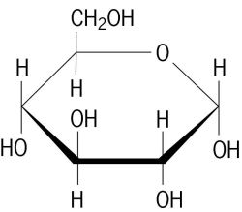 | Fructose  Sucrose  Cellulose | Stores energy  Component of the plant cell wall
Lipids | Triglycerides  Phospholipids  Steroids | 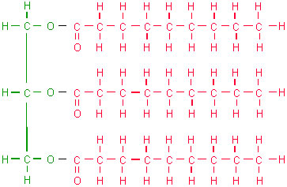 | Butter  Cell membranes  Cholesterol | Energy storage  Are useful as insulation,  Components of cell membranes,  Vitamin absorption, Hormone production.
Proteins | Amino Acids | 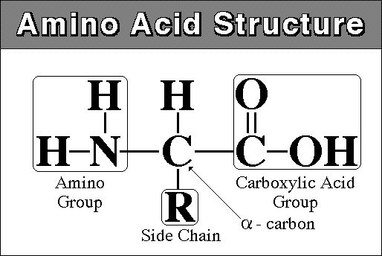 | Enzymes  Hemoglobine  Hair | Build and repairs cell structure  Helps chemical reactions take place (speeds them up)
Nucleic Acid | DNA  RNA | 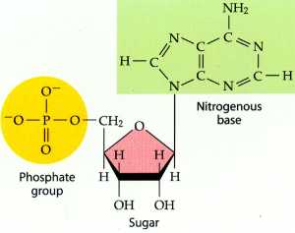 | DNA  RNA | Stores heredity information (DNA)  Decodes Heredity information (RNA)

