Characteristics of Living Organisms

Characteristics | Descriptions
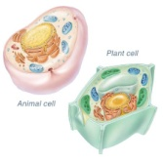  - Living things are made up of cells | Cells are the basis structural unit of life. All living things are composed of one or more cells. Different types of cells have different "jobs" within the organism. Each life form begins from one cell, which then will split. These cells split, and so on.
2. Living things are highly organized  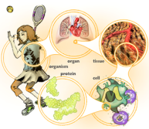 | Living things exhibit a high level of organization, with multi-cellular organisms being subdivided into cells, and cells into organelles, and organelles into molecules, etc
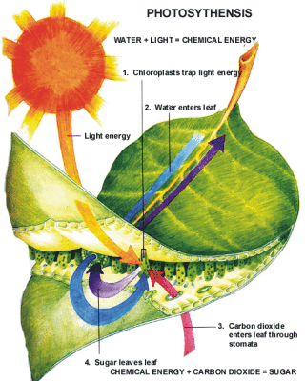  3. Living things require a source of energy | Plants capture energy from the sun. While animals cannot capture the suns energy directly, they can eat plants, plant products or even other animal to get the energy they need.
4. Living things grow  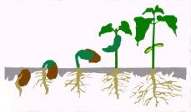 | Even single-celled organisms grow. When first formed by cell division, they are small, and must grow and develop into mature cells.
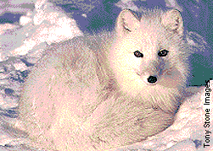  5. Living things can adapt to their environment | Living things are constantly adapting to meet the challenges of their environment. Through adaptation, organisms have been able to develop valuable traits that allow them to survive while others die.
6. Living things reproduce  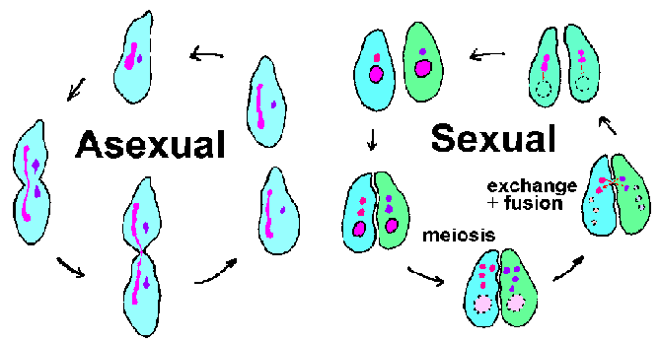 | Since all cells come from existing cells, they must have some way of reproducing, whether that involves asexual or sexual.
7.Living things respond to their surroundings | Being able to respond to danger, and to locate food are two obvious examples of this. Living things also maintain balance inside their body in a process called homeostasis. (Example: the ability of humans to maintain a constant body temperature even though the outside temperature is ever changing.
8. Living things have the ability to move  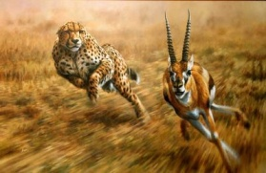 | Many organisms depend on the ability to move to capture food and to escape from danger. While some organisms move quite quickly, plants’ movements are so slow they are difficult to see.

