Lipids

- Lipids are a major source of energy used by cells, however lipids are more difficult for your body to break down. They produce nearly twice the amount of energy than proteins or carbohydrates.

- Lipids are essential in our diets as they:
  - Are useful as insulation,
  - Are necessary components of cell membranes,
  - help absorb vitamins,
  - are even useful in hormone production.

- Lipids are used to store and excess energy from extra carbohydrates in animals
- Lipids are made up of Carbon, Hydrogen, and Oxygen in different proportions than in carbohydrates

There are three groups of Lipids:

Groups | Structure
- Triglycerides  - Most common type of Lipid.  - Made up of one glycerol molecule and three fatty acids linked together by a dehydration synthesis | 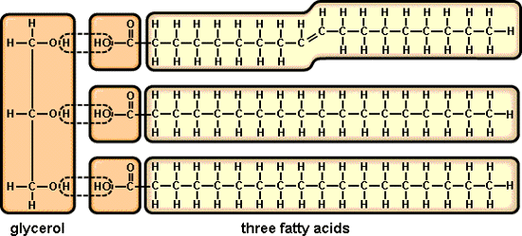

Saturated Fats vs. Unsaturated Fats

Saturated fats

  - Contain as many hydrogen atoms as possible with single bonds between the Carbon atoms
  - Common in animals.
  - Difficult to digest.
  - In general, the greater number of hydrogen atoms, the firmer the fat.

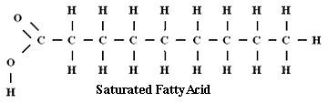

Unsaturated fats

    - Some hydrogen atoms are missing due to the double bonds present in the molecule.
    - Commonly found in plants and are in the oil variety. (canola oil, olive oil, sunflower oil, etc.)

    - Mono-unsaturated fats:
      - Considered to be the healthiest type of fat. Believed to lower cholesterol and may assist in reducing heart disease.
      - Ex. Olive oils, nuts, seeds. Commonly found in plants.
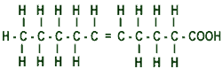

Monsatruated fatty acid

    - Poly-unsaturated fats:
      - Found in vegetable oils like soybean, corn, sunflower and safflower. They also occur in oily fish.
      - Look for Omega-3 fatty acids (EFA’s).

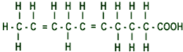

Polyunsaturated fatty acid

Double bonds react more easily, which means the double bonds of the unsaturated fats are more easily broken down for the cells of your body.

But what are Trans fats?

    - Unsaturated fats in foods make it more likely to spoil, so scientists found a way to add hydrogen to these fats, creating hydrogenated fats, or Trans fatty acids.

    - Trans fats tend to raise total blood LDL cholesterol levels.
      - Example: Margarine made of olive oils (BECEL)

Groups | Structure
- Phospholipids  - One of the fatty acid chains is replaced by a phosphate group.  - This forms a polar end that is water soluble.  - This molecule has one end that is water soluble, and one end that is soluble in oils and grease. | 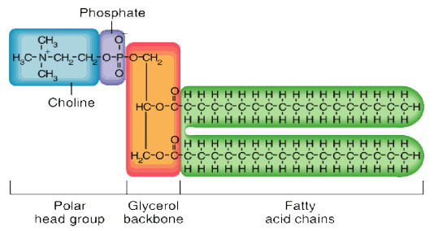
- Steroids(Cholesterol)  - Structurally different from triglycerides and phospholipids  - Material need to synthesis other steroids such as vitamin D, testosterone, and estrogen. | 