Maps: The basic Geographic tool

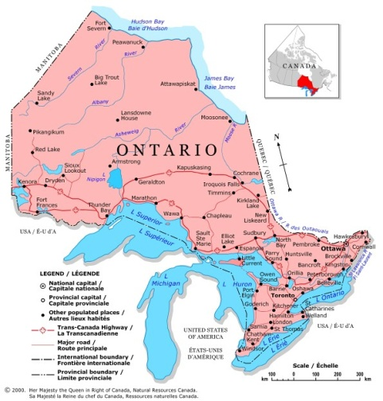
Like many other trades and professions, geographers need effective tools to do their work. The most important one of these tools is the MAP! Maps are extremely useful tools. They:

- Help you visualize the shape of countries
- Locate important features
- Help direct people find their way when traveling.

What is a map?

A MAP is a representation of the Earth's surface on a flat surface. Maps use symbols and colours to represent features of an area. It also simplifies the real world as only certain features are included while others are ignored.

Map Requirements

The following features should be found on all map:

Feature | Explanation

Scales

The scale of a map shows the relationship between the size of an object in real life and its size drawn on the map. Maps can be described as either large scale or small scale.
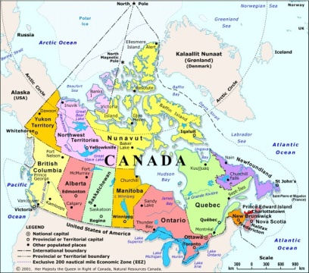

Small-scale map (1:17 500 000): Small-scale maps show a small amount of detail in a very large area. They are use to show more general information.

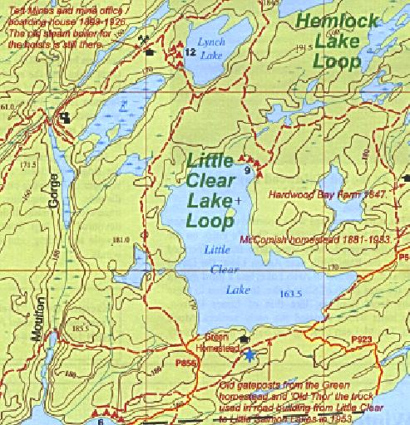

Large-scale map (1:500): Large scale maps show a large amount of detail in a small area. They are used for more detailed tasks such as residential planning and hiking excursions.

Types of maps

There are many types of maps that can be categorized under three main headings: general-purpose maps, thematic maps, and topographic maps.

a) General-purpose maps: provide many types of information on one map. (Bodies of water, roads, railways, park, elevation, towns and cities, longitude and latitude etc.)

b) Thematic maps: provide specific information about a place. These maps are designed to show information on one specific topic. (Climate, demography, economy, environment etc.)

c) Topographic maps: use symbols to chow a variety of features. Two of the most important features are:
- Contour lines - which show a change in elevation
- grid system - that is used to locate places on a map

Symbols found on topographic maps

Using a pencil, draw a symbol that you think would best represent the features found below. Once completed, refer to your textbook to make the necessary changes.

Lake

River

Marsh

International boundary

Dual highway

Highway interchange with number

Hard surface road, all weather
(2 Lanes)

Bridge

Post office

School

Church

House

Mine

Golf course

Campsite

Élévation

