Nucleic acids
DNA and RNA

There are two types of nucleic acids in organisms:

Nucleic acid | Structure
DNA  Deoxyribonucleic acid  Composed of two long nucleotide strands wound around each other like the railing of a circular staircase | 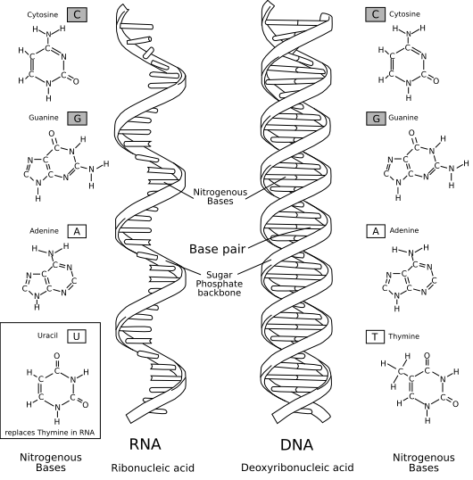
RNA
Ribonucleic acid

Usually composed of a single chain of nucleotides in the form of a helix

Both DNA and RNA a polymers (large molecules composed of long chains of repeating subunits) containing nucleotides. Each one of these nucleotides is made up of three smaller components:

- A sugar
- A phosphate group
- Nitrogenous base

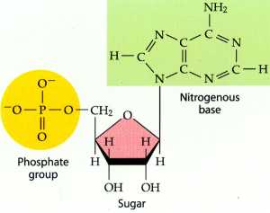
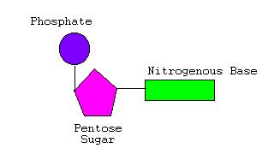

The four (4) nitrogenous bases are called:
- Adenine (A)
- Guanine (G)
- Cytosine (C)
- Thymine(T) (NOTE: RNA does not contain Thymine. It is replaced by Uracil (U) )

These four always pair as follows: A-T (T-A) and G-C (C-G)

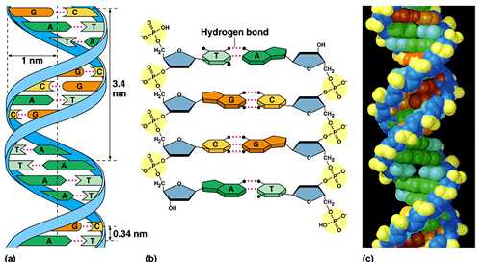

DNA

All chromosomes found in all living things are made of the same chemical known as DNA. DNA found in the nucleus, contains generic information that is passed from one generation to the next. In other words, DNA stores the information, and provides the instructions for making proteins.

The order of nucleotides in DNA forms a code that that specifies the order of amino acids in a particular protein. The set of instructions in DNA that codes a complete protein is called a gene. Proteins cannot be produced without the instructions provided by DNA!!!

What a protein does in a cell is determine by its structure. A DNA molecule contains thousands of base pairs along its length which allows it to code quite a large variety of proteins.

RNA

RNA molecule called messenger RNA (mRNA) take the generic information in DNA out of the nucleus to the ribosomes in the cytoplasm where proteins are produced. DNA molecules remain in the nucleus where they are protected from enzymes in the cytoplasm that might break them down

